
International Studies in English Language and Literary Research

INFLUENCE OF STRATEGIC LEADERSHIP ON ORGANIZATIONAL PERFORMANCE IN THE DIGITAL ERA (Center, Bold, 14ft)
Author Name1, Author Name2 (12ft)
¹ Department, University/Company, City, State/Province, Country/Territorial Region (11ft)
² Department, University/Company, City, State/Province, Country/Territorial Region (11ft)

*Corresponding author: Author Name (Email address) (12ft)
Article History:(12ft) This article is available in:(12ft)
Received : yyyy-mm-dd(11ft) URL(11ft)
Revised : yyyy-mm-dd Accefted : yyyy-mm-dd Published : yyyy-mm-dd

Abstract: (14ft)
It must be concise, structured, and academically rigorous, typically within 250–300 words. It should begin with a brief background that establishes the context and significance of the study, followed by a clear statement of the research objective or primary aim. The methodology should then be summarized, outlining the research design, data sources, or analytical approaches employed. The abstract must present the key findings in a precise and factual manner, avoiding vague or generalized statements. This should be followed by a conclusion that highlights the main outcomes and their relevance to the field. The abstract should be self-contained, allowing readers to understand the study without referring to the full text. It must avoid citations, abbreviations, tables, or figures, and maintain a formal and objective tone throughout. Clarity, coherence, and grammatical accuracy are essential to meet international publication standards. The content should strictly align with the full manuscrift, without introducing new information. (Times New Roman, 12ft.)

Keywords: (12ft)
4–6 relevant keywords should be provided below the abstract to enhance discoverability and indexing efficiency. (Times New Roman, 12ft.)

INTRODUCTION (14ft)
https://doi.org/10.69980/
Introduction section should be written in a clear, formal, and academically rigorous manner, using Times New Roman, 12-point font, with 1.5 line spacing and justified alignment and should be cited appropriately using a consistent referencing style such as APA 7th edition, (Smith, 2020; Johnson & Lee, 2019), as per standard journal formatting requirements. It serves to establish the foundation of the research by presenting the background, rationale, and scope of the study in a coherent and engaging manner. The section should begin with a broad overview of the research area, gradually narrowing down to the specific problem or research gap being addressed. Authors must clearly articulate the motivation behind the study, emphasizing its scientific relevance and practical significance within the existing body of knowledge.

HEADING (Example- Methodology, Results Discussion or Conclusions) (14ft)

This section includes all remaining components of the manuscrift, such as the methodology, results, discussion, and conclusion. The content should be written in Times New Roman, 11-point font, with 1.0 line spacing and justified alignment. All statements, arguments, and findings must be supported with appropriate in-text citations following a consistent referencing style, preferably APA 7th edition.

Sub Heading (12 ft, Bold, Times New Roman)
Use Times New Roman, 12 ft, line spacing 1.5 Align justified. Include citations (Author, Year).

Sub-Sub Heading (12ft, Bold, Italic, Times New Roman)
Use Times New Roman, 12 ft, line spacing 1.5 Align justified. Include citations (Author, Year).

Figures and Tables:

All visual elements, including figures, tables, and photographs, must be presented in high resolution with clear visibility. Proper numbering and caftioning should be followed consistently throughout the manuscrift, as illustrated in the examples below.

Table titles must be positioned above the table and formatted in sentence case. Table 1. Summary of Experimental Results Across Conditions (11 ft)
Variable | Condition A  (Mean ± SD) | Condition B  (Mean ± SD) | p-value
Response Time  (ms) | 250 ± 15 | 230 ± 12 | 0.032*
Accuracy (%) | 85.4 ± 4.2 | 89.7 ± 3.8 | 0.015*
Error Rate (%) | 14.6 ± 4.2 | 10.3 ± 3.8 | 0.018*
*Note: p < 0.05 indicates statistical significance.

All figures and tables must be cited in the text before they appear. Standard referencing formats such as “Fig. 1” or “Figure 1,” and “Table 1” should be used consistently, even when appearing at the beginning of a sentence.

Special attention should be given to figure axis labels, ensuring that descriftive words are used instead of symbols to enhance clarity and understanding.

Result Representation in Template:
The inclusion of properly formatted figures and tables enhances the clarity of results by allowing data to be presented in a structured and visually accessible manner. Tables effectively summarize numerical findings, while figures provide graphical interpretation, making it easier to identify patterns, trends, and comparisons within the study.
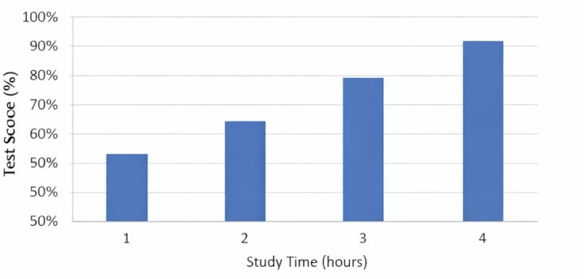
Figure 1. Relationship Between Study Time and Test Performance

Guidelines for Authors

- Figures must be clear, sharp and centre aligned.
- Use Times New Roman (10–11 ft) for all text within the figure, including axis labels, legends, and annotations.
- Axis labels should be descriftive and written in words rather than symbols (e.g., “Study Time (hours)” instead of abbreviations).
- Maintain consistency in font size, style, and formatting across all figures in the manuscrift.
- Ensure that all units, symbols, and abbreviations used in the figure are clearly defined either within the figure or in the caftion.

Caftion Instructions

- Figure caftions must be placed below the figure.
- Caftions should be written in sentence case and center aligned.

REFERENCES:
References in APA style 7th edition, font, size 11, 1.5ft spacing.
Mujica-Johnson, F. N., Concha López, R., Peralta Ferroni, M., & Burgos Henríquez, S. (2024). Gender Perspective in Physical Education Teacher and School Training. Critical analysis in terms of the Chilean context (Gender perspective in Physical Education, teacher training and schooling.

Critical analysis based on the chilean context). Challenges, 55, 339–345.
https://doi.org/10.47197/retos.v55.103535

